# Lab2 Report

1. Code

**\*I wrote code from four tasks into one .m file .**

Lab2.m

clc

fs=1000;% sampling frequency

ts=1/fs; % sampling interval

t=[0:ts:5];% time vector

x=zeros(1,length(t));% input signal initiation

for i=1:length(t)

if t(i)>=0&&t(i)<=2

x(i)=t(i)*sin(100*pi*t(i));

else

x(i)=(sin(pi*t(i))+2)*sin(100*pi*t(i));

end

end

%call function T2F

[f,sf]=T2F(t,x)

%plot the signal

figure(1)

plot(t,x);

xlabel('t');

ylabel('x');

%plot the spectrum

figure(2)

plot(f,abs(sf));

xlabel('f');

ylabel('sf');

%calculate the engry and power

%time_domain

E1=sum(x.*conj(x))*ts;

p1=sum(x.*conj(x))/length(t);

%F-domain

T=length(f)/fs;

E2=sum(sf.*conj(sf))*fs/length(f);

p2=E2/T;

E1

E2

p1

p2

%autocorrelation

R=xcorr(x);

R=R*ts/T;

%Power spectral density£º

P_f_spectrum=abs(sf).^2/T;

%FT of the autocorrelation£º

tau=-5:ts:5;

[f1,R_f]=T2F(tau,R);

figure(3)

plot(tau,R)

figure(4)

plot(f, P_f_spectrum)

figure(5)

plot(f1, abs(R_f))

fc=50;%carrier frequency

x_a=hilbert(x);

x_l=x_a.*exp(-1j*2*pi*fc*t);%lowpass equivalent

[f_l,sf_l]=T2F(t,imag(x_l)); %spectrum

figure(6)

plot(t,imag(x_l))

figure(7)

plot(f_l,abs(sf_l))

1. The resulted figure and discussion
2. Task1:

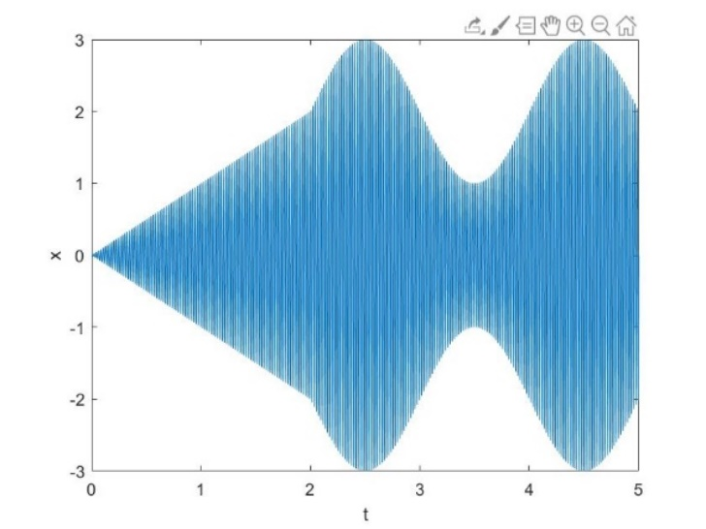

Figure1

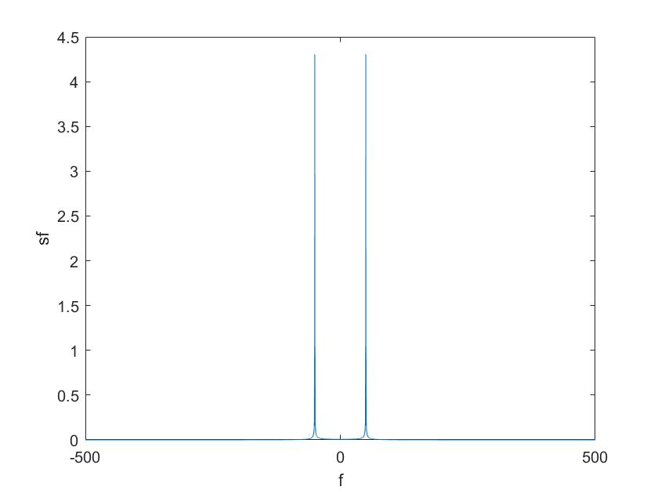

Figure2

Discussion:In the task1,given the signal ,where sampling rate fs=1000,the duration t is from 0 to 5.The expression from 0 to 2 differs from otherwise.So we can use the ‘for’ cycle sentence to state the signal .Then I calling the ‘T2F’ function to do Fourier Transfrom to get the spectrum.

Figure1 is the signal x(t) .Figure 2 is its corresponding spectrum.By enlarging the figure2, I can find the impulses locate -50 and 50 nearby.

1. Task2:

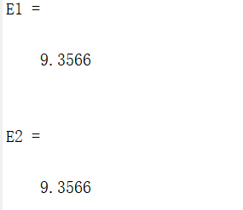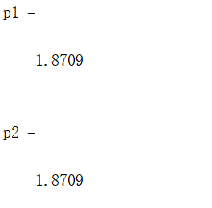

Discussion :Above is the printscreen in the command window .In matlab ,we can ues the formula to calculate the engry and power.I use ‘E1=sum(x.*conj(x))*ts; p1=sum(x.*conj(x))/length(t)’ to cacullate the engry and power of x(t) in the time domain.I ues ‘E2=sum(sf.*conj(sf))*fs/length(f); p2=E2/T’to calculate the engry and power of x(t) in the frequency domain.By contrasting,I can verify E1=E2,P1=P2.

1. Task3:

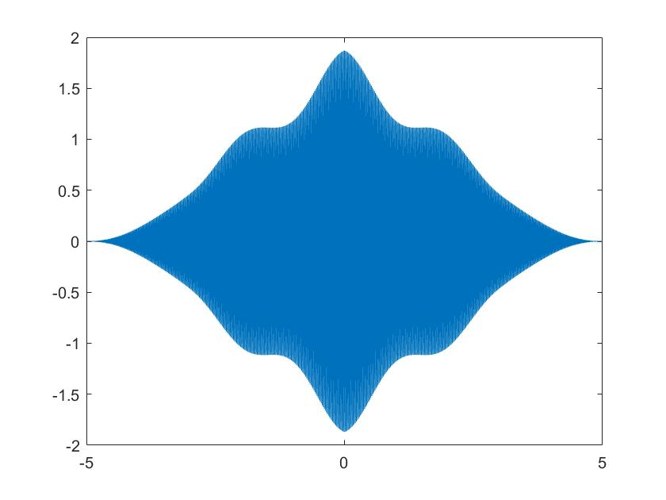

Figure3

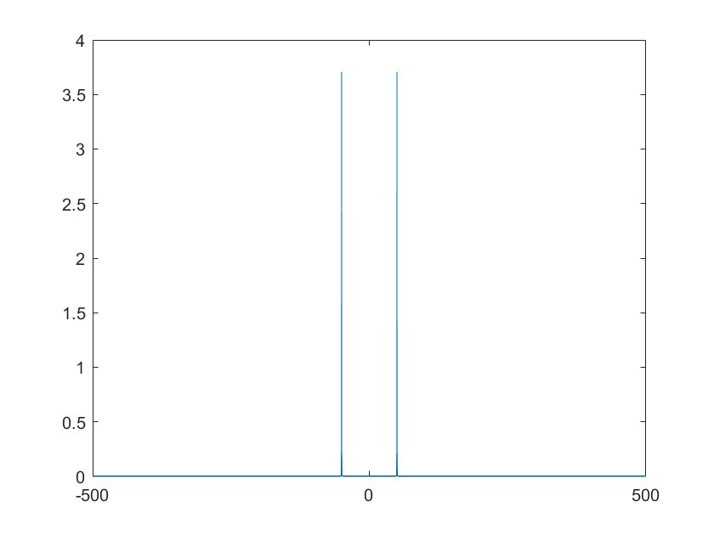

Figure4

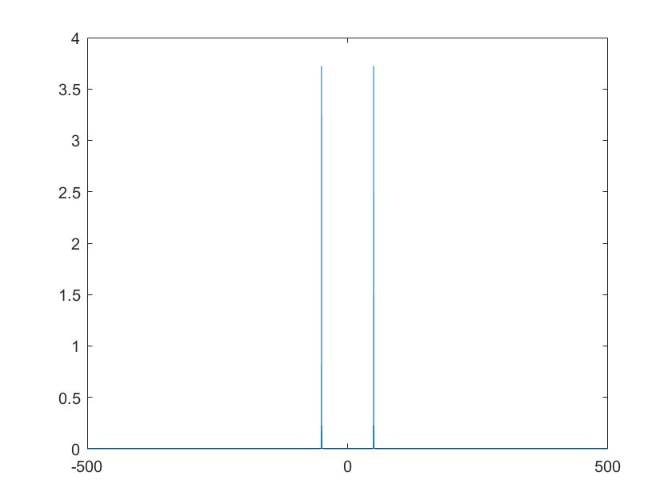

Figure5

Discussion:In the task,we can learn the formula ‘R=xcorr(x)’ to calculate sequence autocorrelation.Then use ‘R*ts/T ‘ to get the time-averaged autocorrelation of x(t).Figure3 is the result.The power spectral density can use ‘P_f_spectrum=abs(sf).^2/T’ to calculate.Figure4 is the power spectral density .When ploting figures,we should notice that the value of ‘tau’ is -5 to 5. Winner-khinchin theorem is the power spectral density

of stationary random signal and its autocorrelation function are Fourier Transfrom pairs of each other. To verify this,we can do FT of the power spectral density of x(t).By cocrasting the figure of power spectral density and the spectrum of R(τ),we find they are consistent.So we can verify it.

1. Task4:

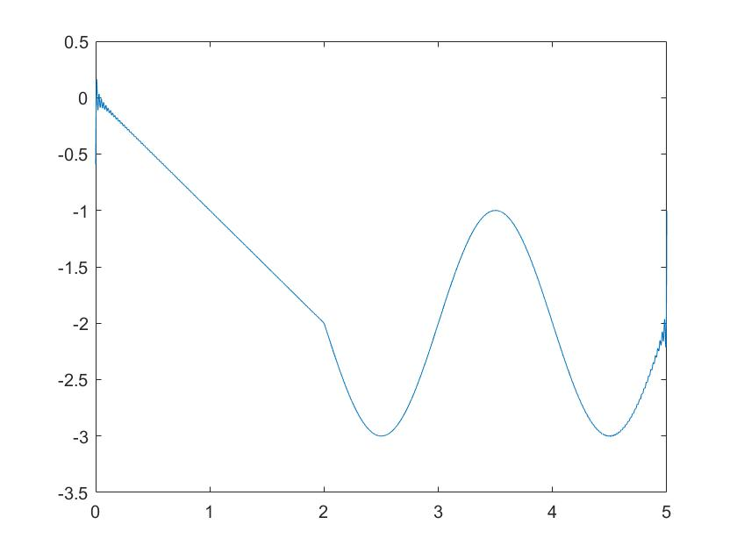

Figure6

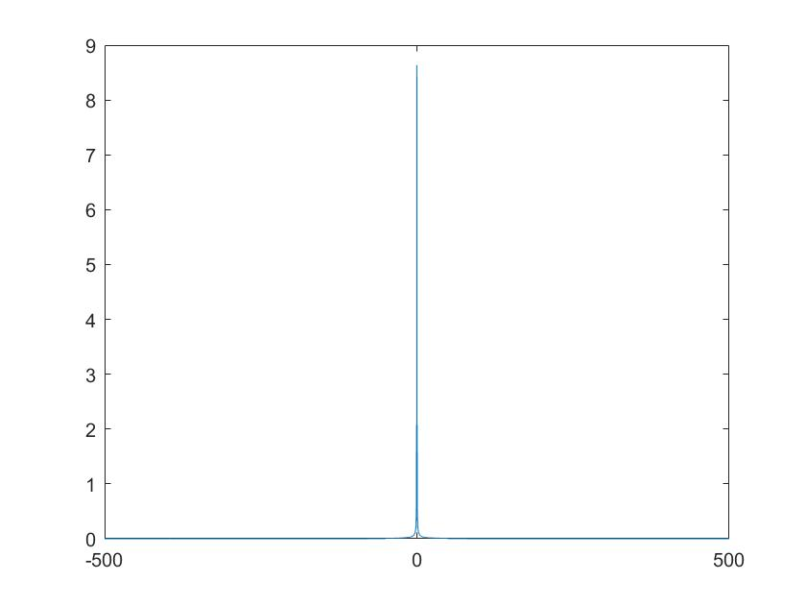

Figure7

Discussion:In the task,first,if I want to get the quadrature component of x(t),I should get its lowpass equivalent.In matlab,we can ues Hilbert.m to introduce complex sequences x_a.Then

use ‘x_a.*exp(-1j*2*pi*fc*t) ‘ .The result is lowpass equivalent x_l of x(t). Figure6 is the corresponding curve.The quadrature component is imanginary part of x_l.Then plot its corresponding spectrum.The signal does not have in-phase component.Because s(t)=sr(t)cos(2*pi*fct)-sc(t)sin(2*pi*fc*t),for fc=50hz,x(t) dosen’ have the part of cos.So s(t) doesn’t have sr(t).Besides,I change ‘ plot (t,iamg(x_l))’ into ‘plot(t,real(x_l))’.Then I get figure8.

we can find the real part of x_l almost is zero.

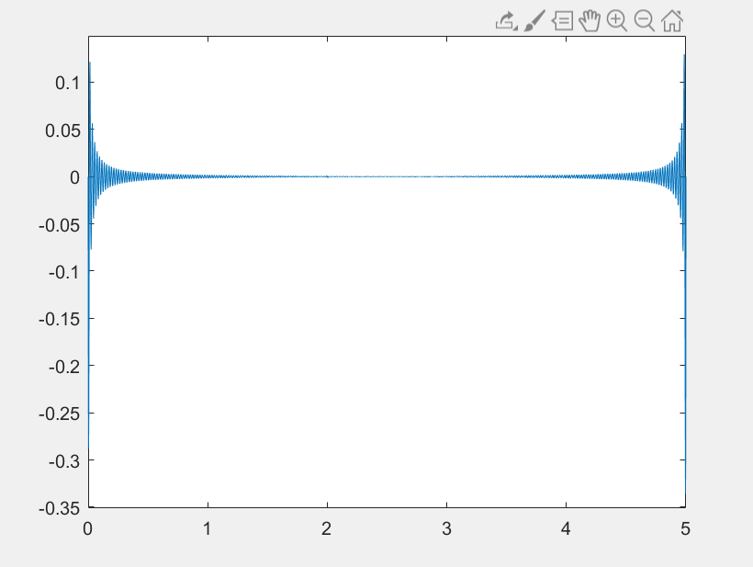

Figure8